Puppet Play Therapy with Children, Teens, and Families

International Puppet Therapy Training (IPT-S) 2020

Facilitator: Elizabeth Kjellstrand Hartwig, PhD, LPC-S, LMFT, RPT-S

Training Description:
Puppet play therapy is the use of puppets in the context of play therapy with children, teens, and families. Puppets serve as a safe medium for children to explore problems and tell their story. This five-day training will take participants on a journey of puppet play therapy skills and interventions with young children, older children, teens, and families. Participants will learn what types of puppets are a good fit for play therapy. In this interactive training, participants will have the opportunity to create a puppet theatre and different puppets each day of the training. Participants will also learn and practice facilitative and directive therapeutic responses that can be used in puppet play, with an emphasis on how to respond in the puppet metaphor. The training will close with a focus on family puppet play therapy.

Training Schedule:

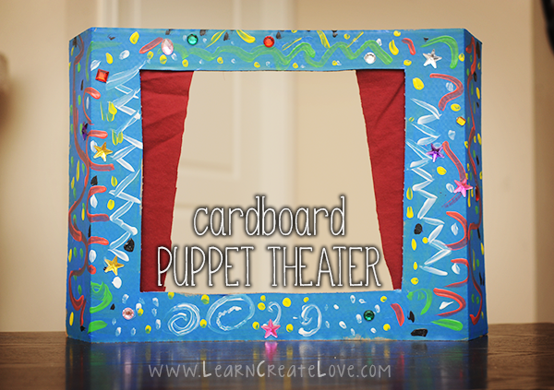 | Day 1: Introduction to Puppet Play Therapy  - Morning: IPT-S participant introductions and foundations of puppet play therapy  - Afternoon: Introduction to play therapy and how puppets are used  - Craft: Puppet theatres
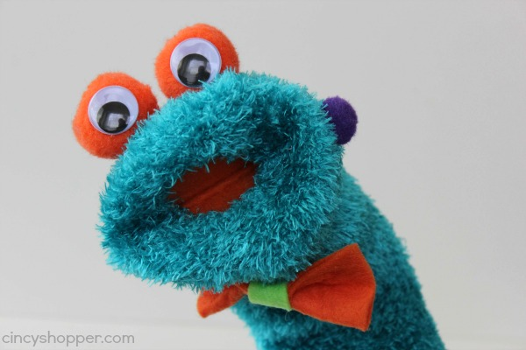 | Day 2: Facilitative Skills with Puppets  - Morning: Practicing non-directive responses in puppet play  - Afternoon: Practicing directive responses in puppet play  - Craft: Monster sock puppets
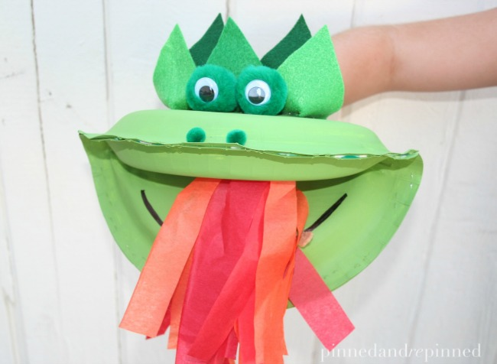 | Day 3: Puppet Bibliotherapy  - Morning: You’ve Got Dragons book and role play  - Afternoon: Bibliotherapy small groups  - Craft: Dragon puppets
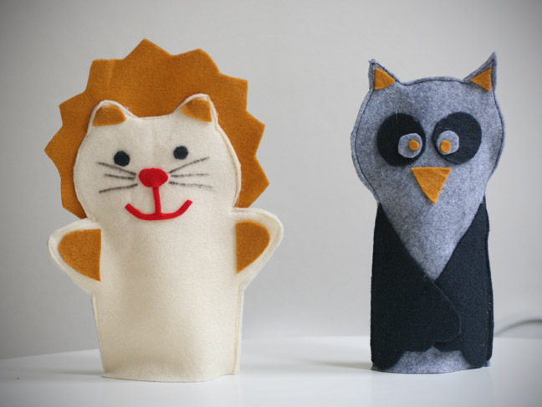 | Day 4: Puppet Storytelling  - Morning: Teen dilemmas and script writing (e.g., bullying, grief, acceptance)  - Afternoon: Teen storytelling puppet shows  - Craft: Felt puppets
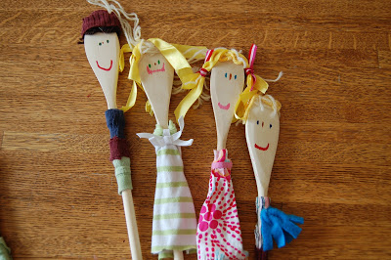 | Day 5: Family Puppet Play Therapy  - Morning: Family Puppet Interview (Gil, 1994)  - Afternoon: Family sculpting with puppets (Haslam, 2010)  - Craft: Family spoon puppets

Target Audience & Disclaimer:
This course is suitable for graduate students or therapists in the mental health field (e.g., counseling, psychology, social work, marriage and family therapy) who are interested in learning and integrating puppet play therapy into their practice. All participants should abide by the ethics and best practices of their disciplines pertaining to scope of practice, education standards, and credentialing.

Facilitator Biography:
Elizabeth Kjellstrand Hartwig, PhD, LPC-S, LMFT, RPT-S, is an Associate Professor in the Professional Counseling Program at Texas State University in San Marcos, TX. Dr. Hartwig has presented on puppets, play therapy, animal-assisted counseling, sandtray, and clinical supervision in local, regional, national, and international conferences. She is a Past President of the Texas Association for Play Therapy and was awarded the Nancy Guillory Award for outstanding service in play therapy in 2017. She's also the Director of the Texas State University Animal-Assisted Counseling Academy. Dr. Hartwig has a private practice in New Braunfels, TX called Pawsitive Family Counseling, LLC, where she works with children, teens, couples, adults, and families. Her favorite play therapy resources are puppets, sandtray, and her canine partner, Ruggles!

Recommended Reading:

Bernier, M., & O’Hare, J. (Eds.) (2005). Puppetry in education and therapy: Unlocking doors to the mind and heart. Bloomington, IN: Authorhouse.

Butler, S., Guterman, J. T., & Rudes, J. (2009). Using puppets with children in narrative therapy to externalize the problem. Journal of Mental Health Counseling, 31(3), 225-233.

Carter, R. B., & Mason, P. S. (1998). The selection and use of puppets in counseling. Professional School Counseling, 1(5), 50-53.

Dillen, L., Siongers, M., Helskens, D., & Eve, L. (2009). When puppets speak: Dialectical psychodrama within developmental child psychotherapy. Journal of Constructivist Psychology, 22(1), 55-82. doi:10.1080/10720530802500839

Gil, E. (2015). Play in family therapy (2nd ed.). New York: Guilford Press.

Hartwig, E. K. (2014). Puppets in the playroom: Utilizing puppets and child-centered facilitative skills as a metaphor for healing. International Journal of Play Therapy, 23(4), 204-216. doi: 10.1037/a0038054

Irwin, E. C. (2002). Using puppets for assessment. In C.E. Schaefer & D. Cangelosi (Eds.). Play therapy techniques (2nd ed., pp.101-113). Northvale, NJ: Jason Aronson, Inc.

Irwin, E. C. & Malloy, E. S. (1994). Family puppet interview. In C. E. Schaefer & L. Carey (Eds.), Family play therapy (pp. 21-33). New York: Jason Aronson.

Landreth, G. (2012). Play therapy: The art of the relationship (3rd ed.). New York: Brunner Routledge.

Schaefer, C., & Drewes, A. (Eds.). (2017). Puppet play therapy: A practical guidebook. New York, NY: Taylor & Francis.

